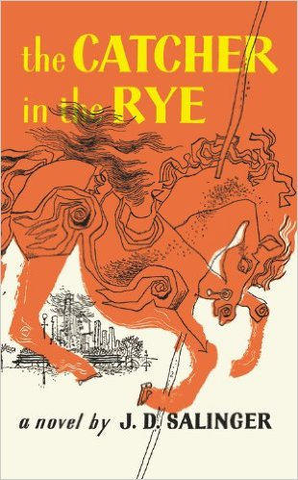
Themes
Evidence and Analysis

Directions: A theme is a concept or idea that an author explores in a literary work. For each theme, collect 5-6 details from The Catcher in the Rye (such as specific plot points, symbols, or quotes) that the author uses to explore that theme and enter them in the Evidence section of the table.

Next, use the evidence you’ve collected to write a Theme Description that explains the role of the theme in The Catcher in the Rye. Your Theme Description should be 1-2 paragraphs. Here are some questions to consider as you write each Theme Description:

- How do the ideas or actions of the main characters reflect different aspects of the theme?
- Does the theme develop or change over the course of The Catcher in the Rye? If so, how?
- If your evidence includes symbols, explain how the author uses those symbols to explore the theme.
- If your evidence includes specific quotes from the text, explain how those quotes provide examples of how the theme applies to The Catcher in the Rye?

Phoniness
Evidence
1. | 2. | 3.
4. | 5. | 6.

Theme Description

Alienation and Meltdown
Evidence
1. | 2. | 3.
4. | 5. | 6.

Theme Description

Women and Sex
Evidence
1. | 2. | 3.
4. | 5. | 6.

Theme Description

Childhood and Growing Up
Evidence
1. | 2. | 3.
4. | 5. | 6.

Theme Description

Madness, Depression, Suicide
Evidence
1. | 2. | 3.
4. | 5. | 6.

Theme Description

