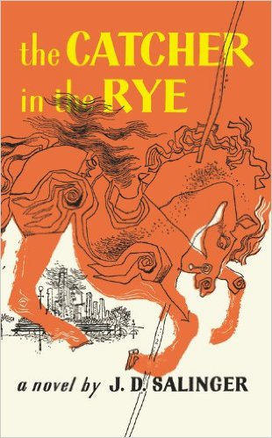 | Holden Caulfield  Evidence and Analysis  Directions: Gather quotes and other examples from the text to use as evidence that provides insight into Holden Caulfield. Then write a paragraph that describes and analyzes Holden Caulfield, including relationships, traits, motivations, fears, and how (or if) they develop over the course of the text.

Evidence
1. | 2. | 3.
4. | 5. | 6.

Character Description and Analysis

Phoebe Caulfield
Evidence and Analysis

Directions: Gather quotes and other examples from the text to use as evidence that provides insight into Phoebe Caulfield. Then write a paragraph that describes and analyzes Phoebe Caulfield, including relationships, traits, motivations, fears, and how (or if) they develop over the course of the text.

Evidence
1. | 2. | 3.
4. | 5. | 6.

Character Description and Analysis

Mr. Antolini
Evidence and Analysis

Directions: Gather quotes and other examples from the text to use as evidence that provides insight into Mr. Antolini. Then write a paragraph that describes and analyzes Mr. Antolini, including relationships, traits, motivations, fears, and how (or if) they develop over the course of the text.

Evidence
1. | 2. | 3.
4. | 5. | 6.

Character Description and Analysis

