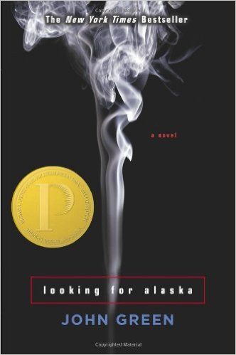 | Miles Halter  Evidence and Analysis  Directions: Gather quotes and other examples from the text to use as evidence that provides insight into Miles Halter . Then write a paragraph that describes and analyzes Miles Halter , including relationships, traits, motivations, fears, and how (or if) they develop over the course of the text.

Evidence
1. | 2. | 3.
4. | 5. | 6.

Character Description and Analysis

Chip Martin (The Colonel)
Evidence and Analysis

Directions: Gather quotes and other examples from the text to use as evidence that provides insight into Chip Martin (The Colonel). Then write a paragraph that describes and analyzes Chip Martin (The Colonel), including relationships, traits, motivations, fears, and how (or if) they develop over the course of the text.

Evidence
1. | 2. | 3.
4. | 5. | 6.

Character Description and Analysis

Alaska Young
Evidence and Analysis

Directions: Gather quotes and other examples from the text to use as evidence that provides insight into Alaska Young. Then write a paragraph that describes and analyzes Alaska Young, including relationships, traits, motivations, fears, and how (or if) they develop over the course of the text.

Evidence
1. | 2. | 3.
4. | 5. | 6.

Character Description and Analysis

Takumi Hikohito
Evidence and Analysis

Directions: Gather quotes and other examples from the text to use as evidence that provides insight into Takumi Hikohito . Then write a paragraph that describes and analyzes Takumi Hikohito , including relationships, traits, motivations, fears, and how (or if) they develop over the course of the text.

Evidence
1. | 2. | 3.
4. | 5. | 6.

Character Description and Analysis

Mr. Starnes (The Eagle)
Evidence and Analysis

Directions: Gather quotes and other examples from the text to use as evidence that provides insight into Mr. Starnes (The Eagle). Then write a paragraph that describes and analyzes Mr. Starnes (The Eagle), including relationships, traits, motivations, fears, and how (or if) they develop over the course of the text.

Evidence
1. | 2. | 3.
4. | 5. | 6.

Character Description and Analysis

Dr. Hyde (The Old Man)
Evidence and Analysis

Directions: Gather quotes and other examples from the text to use as evidence that provides insight into Dr. Hyde (The Old Man). Then write a paragraph that describes and analyzes Dr. Hyde (The Old Man), including relationships, traits, motivations, fears, and how (or if) they develop over the course of the text.

Evidence
1. | 2. | 3.
4. | 5. | 6.

Character Description and Analysis

Kevin
Evidence and Analysis

Directions: Gather quotes and other examples from the text to use as evidence that provides insight into Kevin. Then write a paragraph that describes and analyzes Kevin, including relationships, traits, motivations, fears, and how (or if) they develop over the course of the text.

Evidence
1. | 2. | 3.
4. | 5. | 6.

Character Description and Analysis

