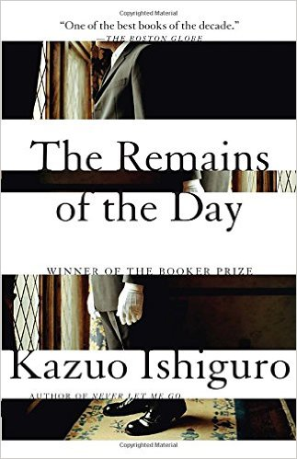 | Mr. Stevens  Evidence and Analysis  Directions: Gather quotes and other examples from the text to use as evidence that provides insight into Mr. Stevens. Then write a paragraph that describes and analyzes Mr. Stevens, including relationships, traits, motivations, fears, and how (or if) they develop over the course of the text.

Evidence
1. | 2. | 3.
4. | 5. | 6.

Character Description and Analysis

Miss Kenton (Mrs. Benn)
Evidence and Analysis

Directions: Gather quotes and other examples from the text to use as evidence that provides insight into Miss Kenton (Mrs. Benn). Then write a paragraph that describes and analyzes Miss Kenton (Mrs. Benn), including relationships, traits, motivations, fears, and how (or if) they develop over the course of the text.

Evidence
1. | 2. | 3.
4. | 5. | 6.

Character Description and Analysis

Lord Darlington
Evidence and Analysis

Directions: Gather quotes and other examples from the text to use as evidence that provides insight into Lord Darlington . Then write a paragraph that describes and analyzes Lord Darlington , including relationships, traits, motivations, fears, and how (or if) they develop over the course of the text.

Evidence
1. | 2. | 3.
4. | 5. | 6.

Character Description and Analysis

Mr. John Farraday
Evidence and Analysis

Directions: Gather quotes and other examples from the text to use as evidence that provides insight into Mr. John Farraday. Then write a paragraph that describes and analyzes Mr. John Farraday, including relationships, traits, motivations, fears, and how (or if) they develop over the course of the text.

Evidence
1. | 2. | 3.
4. | 5. | 6.

Character Description and Analysis

William Stevens, senior (Stevens’s father)
Evidence and Analysis

Directions: Gather quotes and other examples from the text to use as evidence that provides insight into William Stevens, senior (Stevens’s father). Then write a paragraph that describes and analyzes William Stevens, senior (Stevens’s father), including relationships, traits, motivations, fears, and how (or if) they develop over the course of the text.

Evidence
1. | 2. | 3.
4. | 5. | 6.

Character Description and Analysis

Mr. Graham
Evidence and Analysis

Directions: Gather quotes and other examples from the text to use as evidence that provides insight into Mr. Graham . Then write a paragraph that describes and analyzes Mr. Graham , including relationships, traits, motivations, fears, and how (or if) they develop over the course of the text.

Evidence
1. | 2. | 3.
4. | 5. | 6.

Character Description and Analysis

Sir David Cardinal
Evidence and Analysis

Directions: Gather quotes and other examples from the text to use as evidence that provides insight into Sir David Cardinal. Then write a paragraph that describes and analyzes Sir David Cardinal, including relationships, traits, motivations, fears, and how (or if) they develop over the course of the text.

Evidence
1. | 2. | 3.
4. | 5. | 6.

Character Description and Analysis

Mr. Lewis
Evidence and Analysis

Directions: Gather quotes and other examples from the text to use as evidence that provides insight into Mr. Lewis. Then write a paragraph that describes and analyzes Mr. Lewis, including relationships, traits, motivations, fears, and how (or if) they develop over the course of the text.

Evidence
1. | 2. | 3.
4. | 5. | 6.

Character Description and Analysis

M. Dupont
Evidence and Analysis

Directions: Gather quotes and other examples from the text to use as evidence that provides insight into M. Dupont . Then write a paragraph that describes and analyzes M. Dupont , including relationships, traits, motivations, fears, and how (or if) they develop over the course of the text.

Evidence
1. | 2. | 3.
4. | 5. | 6.

Character Description and Analysis

Lisa
Evidence and Analysis

Directions: Gather quotes and other examples from the text to use as evidence that provides insight into Lisa. Then write a paragraph that describes and analyzes Lisa, including relationships, traits, motivations, fears, and how (or if) they develop over the course of the text.

Evidence
1. | 2. | 3.
4. | 5. | 6.

Character Description and Analysis

