Close Reading Organizer - Chapter 26

Directions: Read each summary entry and think about which themes listed in the Themes Key apply to it, then color in those themes in the Theme Tracker. Next, write a few sentences of Analysis to explain how the themes you chose apply to each summary section.
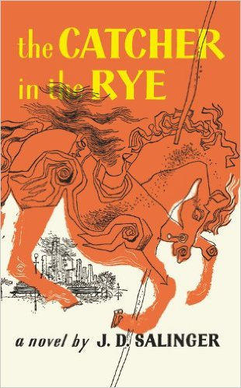
Themes Key
1 | Phoniness
2 | Alienation and Meltdown
3 | Women and Sex
4 | Childhood and Growing Up
5 | Madness, Depression, Suicide

Summary | Theme Tracker |  |  |  |  | Your Analysis
Holden ends the novel by refusing to say what happened after the carousel other than that he got sick and was sent to the rest home he currently occupies. He mentions that a psychoanalyst asked him if he'll apply himself when he returns to a new school in the fall. Holden says he thinks so, but adds that you won't know what you're going to do until you do it. | 1 | 2 | 3 | 4 | 5
In fact, Holden says that he now wishes that he hadn't talked so much about what happened to him, and wishes he'd said less to D.B., who often comes to visit him. Holden advises readers not to tell their own stories, because it will just make them miss everyone they tell about. He even misses Ackley and Stradlater now. | 1 | 2 | 3 | 4 | 5

